***A Mini Project Synopsis on***

**<Nature’s Symphony>**

**(Discovering Floral & Avian Wonders)**

**S.E. – Computer Science and Engineering-Data Science**

**Submitted By**

**<Sanchit Patil> 21107001**

**<Vanshika Salve> 21107010**

**<Khushi Chhoker> 21107055**

**Under The Guidance Of**

**< Aavani Nair >**



**DEPARTMENT OF CSE-DATA SCIENCE**

A.P.SHAH INSTITUTE OF TECHNOLOGY

G.B. Road, Kasarvadavali, Thane (W), Mumbai-400615

UNIVERSITY OF MUMBAI

**Academic year : 2023-24**

**CERTIFICATE**

This to certify that the Mini Project report on <**Nature’s Symphony**> has been submitted by **Sanchit Patil (21107001), Vanshika Salve (21107010), and Khushi Chhoker (21107055**) who are a Bonafede students of A. P. Shah Institute of Technology, Thane, Mumbai, as a partial fulfilment of the requirement for the degree in **Computer Science**

**and Engineering(Data Science)**, during the academic year **2023-2024** in the satisfactory

manner as per the curriculum laid down by University of Mumbai.

Ms.<Aavani Nair> Guide

Prof. Anagha Aher Dr. Uttam D.Kolekar

Head Department of CSE-Data Science Principal

External Examiner(s)

1.

2.

Place: A. P. Shah Institute of Technology, Thane

Date:

**TABLE OF CONTENTS**

1. Introduction.......................................................................................................... 1

1.1.Purpose..................................................................................................... 1

1.2.Objectives................................................................................................. 1

1.3.Scope........................................................................................................ 2

2. Problem Definition………………….................................................................... 3

3. Proposed System………....................................................................................... 4

3.1. Features and Functionality…………………………………………………..4

4. Project Outcomes.................................................................................................. 7

5. Software Requirements ........................................................................................ 8

6. Project Design........................................................................................................9

7. Project Scheduling..................................................................................................15

8. Conclusion..............................................................................................................16

**Chapter 1**

**Introduction**

In a world where technology and nature sometimes seem at odds, there exists a unique synergy between the two that offers the promise of a more harmonious coexistence. "Nature's Symphony," our innovative system, is the manifestation of this collaboration, designed to predict the different types of flower species and the migration patterns of various bird species through the intricate analysis of numerous environmental factors. This remarkable project is not merely a display of scientific prowess; it is a bridge connecting humanity with the natural world. It addresses a critical problem: the limited ability to predict and understand the behaviors of birds and various flower species in their natural ecosystems. By doing so, it provides a user- friendly solution that empowers individuals to easily identify different species of birds and flowers, ultimately fostering a deeper appreciation of and connection with the world that surrounds us.

Our world is home to an astonishing array of bird and flower species, each of which contributes to the rich tapestry of life on Earth. However, understanding and predicting the behaviors and movements of these species in their natural habitats have often been fraught with challenges. Traditional methods for identification and tracking are time-consuming, labor-intensive, and often fraught with inaccuracies. Observing bird migration patterns, for instance, involves extensive fieldwork and painstaking data collection, which is not always feasible. Similarly, distinguishing between flower species in diverse ecosystems can be daunting, especially for those without specialized botanical knowledge.

Furthermore, as our planet faces ever-increasing environmental challenges, such as habitat loss and climate change, the need for accurate and efficient means of monitoring these species has never been more pressing. The ability to comprehensively comprehend the behaviors and needs of birds and flowers is vital for their conservation, and it also offers unique insights into the health of our ecosystems.

"Nature's Symphony" offers a groundbreaking solution to these problems by leveraging the power of artificial intelligence and machine learning. This system serves as a bridge between the complexities of the natural world and the everyday lives of people, democratizing the knowledge of birds and flowers. Users can effortlessly identify different bird and flower species by simply inputting their observations and data into the system. The system then analyzes an array of factors, including environmental conditions, migratory patterns, plumage, and floral characteristics, and provides instant, accurate results.

This technology has the potential to revolutionize the way we connect with and understand the natural world. It not only makes the process of species identification accessible to everyone, from the seasoned naturalist to the curious amateur, but also contributes to vital conservation efforts by offering valuable data for the protection of these species and their habitats.

In the pages that follow, we will take an in-depth look at the intricacies of "Nature's Symphony," exploring its functionality, the science behind its predictions, and the profound impact it can have on our relationship with nature. We invite you to join us on this journey of discovery, as we unlock the potential of this remarkable system in harmonizing human technology with the wonders of the natural world.

**1.1 Purpose**

The purpose of a Bird and Flower Prediction System is multifaceted, as it serves to fulfill several critical objectives. Firstly, it contributes to the conservation of biodiversity by accurately predicting and identifying bird and flower species, facilitating the monitoring and protection of these species and their habitats in the face of environmental challenges. Secondly, it acts as an invaluable tool for environmental education, making knowledge about the natural world more accessible and promoting a deeper connection to the environment, thus fostering a sense of responsibility towards nature. Thirdly, the system aids in assessing the health of ecosystems by tracking the presence of birds and the types of flowers in an area, offering insights into ecological balance. Moreover, it plays a crucial role in scientific research, providing

valuable data for researchers in the fields of ecology, ornithology, and botany. This data aids in the development of a deeper understanding of bird migration patterns, flowering seasons, and other ecological dynamics. Lastly, these systems support the monitoring of wildlife populations, especially migratory birds, essential for understanding population trends, the impact of environmental changes, and the effective management of protected areas and wildlife reserves. In essence, a Bird and Flower Prediction System is a versatile tool that connects technology with nature, benefiting both conservation efforts and the enrichment of our understanding of the natural world.

**1.2 Objectives**

The Bird and Flower Prediction System has a multifaceted purpose, encompassing a range of critical objectives. Firstly, it serves as a powerful tool to identify and classify various bird and flower species. By seamlessly integrating artificial intelligence and data analysis, it offers an efficient means to distinguish these species, contributing to scientific research and environmental conservation.

Additionally, this system goes beyond mere identification. It delves into the behaviors of birds and specific types of flowers, offering the ability to analyze and predict their actions. This predictive capability is instrumental in understanding migration patterns, flowering cycles, and the intricate relationships between these organisms.

The system's impact extends to environmental assessment as well. By identifying areas of high biodiversity, it plays a pivotal role in recognizing ecologically significant regions, aiding in the preservation of critical habitats and the diverse species they support.

Moreover, the system acts as an educational tool, enriching users with knowledge about birds and flowers. It democratizes access to information, fostering a deeper connection to the natural world and promoting environmental awareness.

Furthermore, it contributes to the analysis of long-term trends in bird and flower populations. By compiling data over extended periods, it offers valuable insights into population dynamics, supporting conservation efforts and scientific research.

Lastly, the Bird and Flower Prediction System prioritizes accessibility with user- friendly interfaces. It ensures that technology's benefits are available to a broad audience, from researchers and naturalists to everyday individuals seeking a deeper understanding of the environment. In sum, this system's multifaceted purpose transcends mere species identification, empowering users with knowledge, supporting conservation, and aiding in the understanding and preservation of the natural world.

**1.3 Scope**

The application of Bird and Flower Prediction Tools extends beyond the realms of pure natural exploration, having significant implications in various fields. One such area is tourism and birdwatching, where these tools prove invaluable to tourist guides and birdwatching enthusiasts. They enable the precise identification and location of specific bird species in different regions, enhancing the overall birdwatching experience. This not only attracts more tourists but also contributes to a better understanding of the local bird populations, ultimately supporting conservation efforts.

In agriculture, the prediction tools open up a new dimension of decision-making. Farmers can make informed planting choices based on predicted birds-flower interactions. Understanding which birds are likely to be attracted to specific flower species can aid in designing more ecologically sound and sustainable agricultural practices. By aligning planting choices with local bird populations, farmers can create environments that benefit both agriculture and the surrounding ecosystems.

Urban planning is yet another area that can leverage the insights provided by these tools. In the context of designing cities and parks, understanding the types of birds and flowers in an area can inform decisions that lead to more environmentally friendly and sustainable urban spaces. This can include planting flower species that attract specific

birds or creating green spaces that cater to the local avian population, contributing to improved biodiversity and ecological balance within urban environments.

Additionally, the tools play a crucial role in disease monitoring. Some diseases are closely linked to the presence or behavior of certain birds. Predicting the presence of these birds can prove instrumental in monitoring and controlling disease outbreaks. By providing early warning systems based on bird behavior patterns, public health agencies can take proactive measures to protect both human and avian populations.

In summary, Bird and Flower Prediction Tools offer a diverse range of applications, from enhancing tourism experiences to revolutionizing agriculture and urban planning, as well as contributing to disease monitoring and control. These tools exemplify the broader integration of technology with the natural world, fostering a more sustainable and interconnected coexistence between humans and the environment.

**Chapter 2**

**Problem Identified**

The natural world is a vast and intricate tapestry, where countless species of birds and flowers coexist and interact within complex ecosystems. However, despite our admiration for the beauty and diversity of these species, there has long been a recognized limitation in our ability to predict and understand their behaviors within their natural environments. This challenge has hindered our efforts to grasp the intricacies of bird migration patterns, the flowering seasons of various species, and the interconnected relationships between birds and flowers in the wild.

The absence of accurate prediction tools has made it difficult for scientists, conservationists, and nature enthusiasts to gain a comprehensive understanding of these organisms' behaviors. Traditional methods of observation and data collection are often labor-intensive and do not provide the real-time insights needed to make informed decisions about conservation, agricultural practices, or urban planning. This

limited ability to predict and understand the behaviors of birds and various flower species in their natural ecosystems has not only impeded our ability to protect and preserve these species but has also hampered our broader understanding of the intricate ecological dance that sustains life on our planet.

Recognizing this problem has spurred the development of innovative Bird and Flower Prediction Systems, which integrate technology, artificial intelligence, and ecological expertise to unlock the mysteries of nature. These systems offer a solution to the long- standing problem by providing accurate and real-time predictions regarding bird migration, flowering patterns, and the interactions between these species. They bridge the gap between nature and technology, empowering us to better appreciate, protect, and coexist harmoniously with the natural world. In the pages that follow, we delve into the transformative potential of these systems and their impact on our understanding of birds and flowers in their natural habitats, marking a promising step toward a more informed and sustainable coexistence with our natural environment.

**Chapter 3**

**Solution Proposed**

The proposed solution is both elegant and transformative in its simplicity: to empower users with the ability to easily identify different species of birds and flowers. This user-friendly approach not only democratizes access to the intricate world of avian and botanical diversity but also enriches the lives of individuals by fostering a deeper connection with the natural world. By providing a straightforward means for users, regardless of their level of expertise, to distinguish and appreciate various bird and flower species, the solution transcends traditional barriers of knowledge and access. It facilitates a harmonious coexistence with nature, promoting environmental awareness and conservation efforts as users become more adept at recognizing, understanding, and protecting the vast array of species that share our planet. In essence, this solution not only simplifies the complexities of the natural world but also represents a profound step toward a more enlightened and sustainable relationship between humanity and the environment.

**3.1 Features and Functionality**

• User can predict species of birds by selecting Floral by providing following inputs

i. Color ii. No of androecium iii. No of gynoecium iv. Sitgma v. Style

• Their germination route can be tracked.

- Within the Bird and Flower Prediction System, the "Floral" pathway empowers users to predict bird species by inputting specific floral characteristics. By providing details such as color, the number of androecium, gynoceium, stigma, and style, users gain the ability to accurately identify birds that are associated with particular flower species. This not only enhances our understanding of avian-plant interactions but also enables users to track the germination route of these interactions. By offering insights into the influence of bird species on plant growth and bud development, the system provides a unique perspective on the intricate relationships that shape our natural world.

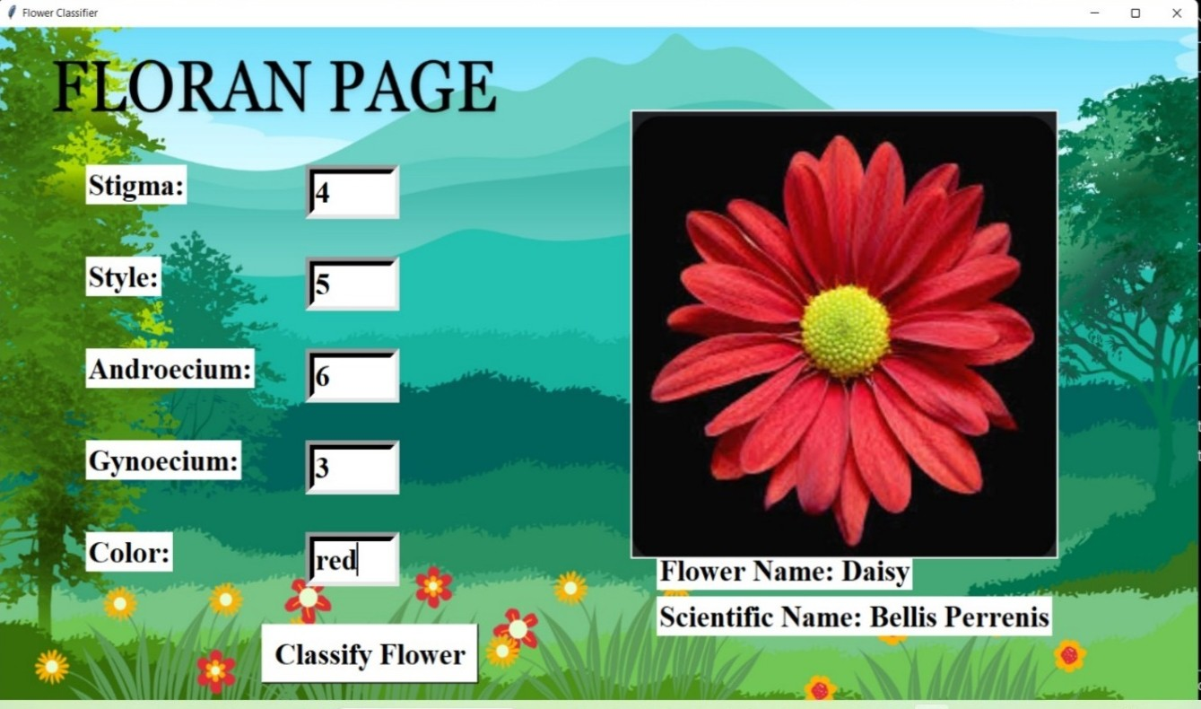

• User can predict species of birds by selecting Avian by providing following inputs

i. primary colour ii. Secondary colour iii. no of legs\hands iv. Flight v. zone

• Their germination wave can be tracked.

- Through the "Avian" selection within the Bird and Flower Prediction System, users can immerse themselves in the world of birds with precision and ease. By inputting a set of specific avian characteristics, including primary and secondary colors, the number of legs or wings, flight capabilities, and their geographic zone, users gain the ability to accurately predict bird species. However, this pathway doesn't stop at identification alone. It also offers the remarkable capability to track the migration wave of these birds, providing invaluable insights into the migratory patterns of different species. This feature enriches our understanding of bird behaviors and their interactions with various environments, enhancing our appreciation for the avian world's intricacies.

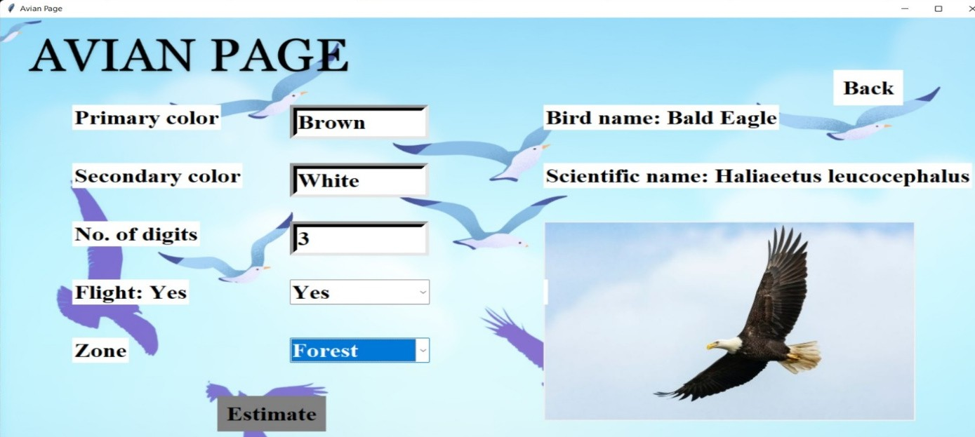

•In migration page, if user enters bird name, he can get graphs or life span vs distance travelled and life span vs total birds migrated

- Within the Bird and Flower Prediction System's "Migration" page, a wealth of information awaits users, enhancing our understanding of avian behaviors and interactions. By entering a specific bird's name, users gain access to a valuable visual representation of its migratory journey. The system generates comprehensive graphs that illustrate the bird's life span in relation to the distance it travels and its total contribution to migration. These insights offer a deep dive into the complex world of avian migration, shedding light on the factors that influence birds' life spans and their roles within broader migratory patterns. This feature not only enriches our knowledge of birds but also serves as a powerful educational tool for scientists, birdwatchers, and nature enthusiasts, fostering a greater appreciation for the remarkable phenomenon of avian migration.

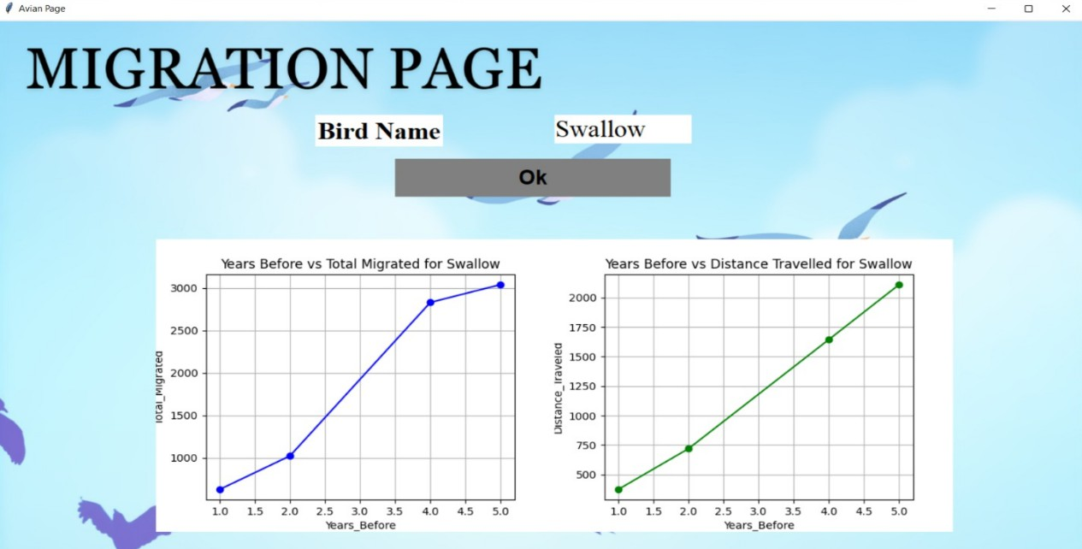

•In germination page, if user enters Bird name, graph of no. of days vs height of plant and no of days vs bud count will be shown

- In the "Germination" page of the Bird and Flower Prediction System, an intriguing window into the interactions between birds and plant life unfolds. Users can enter the name of a specific bird, and the system responds with illuminating graphs that unveil the impact of that bird on the germination process. These graphs chart the relationship between the number of days and the height of plant growth, offering insights into how the presence of a particular bird species influences the development of plants over time. Additionally, users can explore the connection between the number of days and bud count, further revealing the intricate interplay between avian activity and the reproductive processes of various flower species. This feature not only provides a fascinating glimpse into the ecological dynamics at play but also serves as a valuable educational resource, deepening our understanding of the profound influence birds have on the growth and reproductive cycles of plants in the natural world.

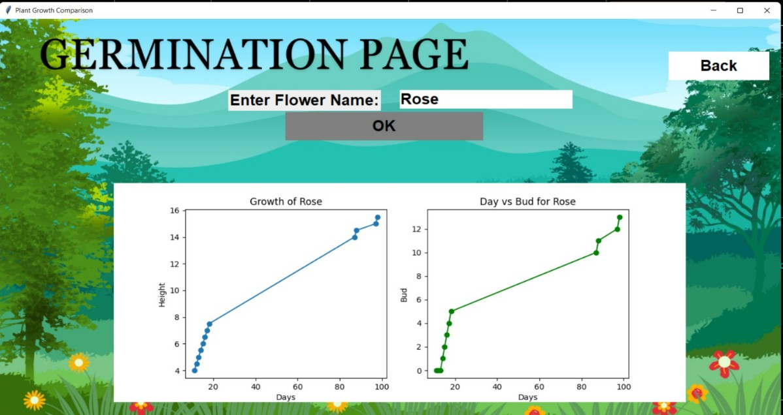

**Chapter 4**

**Project Outcomes**

•**User can register & login\log out :**

- The Bird and Flower Prediction System places a strong emphasis on user experience and personalization. To facilitate this, users are provided with the convenience of registering for an account, subsequently allowing them to log in and, when needed, log out. This feature enhances the overall security and tailored experience for each user, enabling them to maintain a personalized profile while interacting with the system's various functionalities.

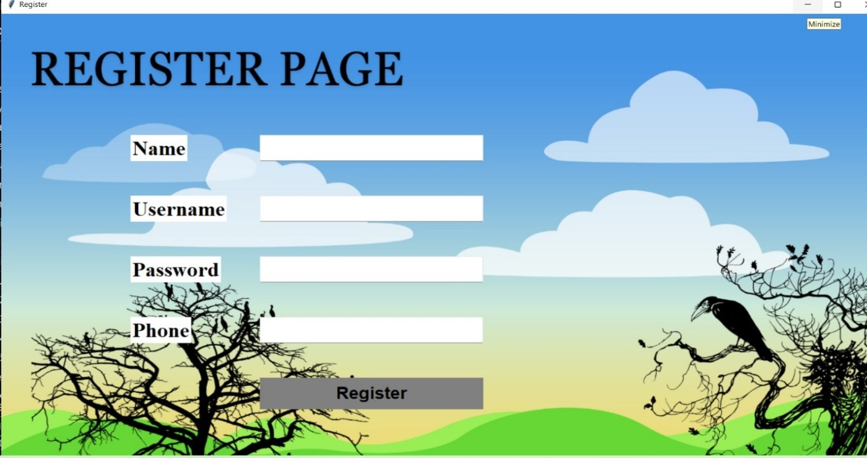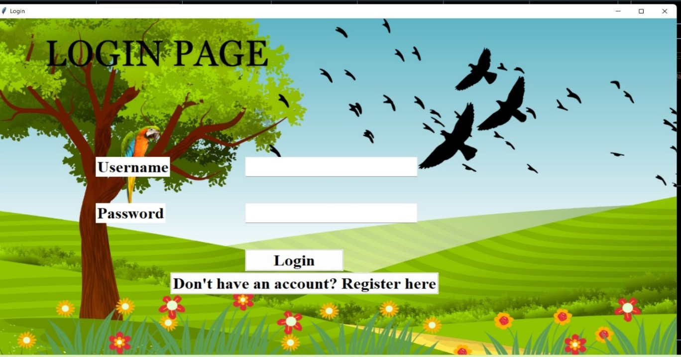

•**User can predict flower and birds using two options Avian & Floral :**

- At the heart of the system's versatility are the two distinct options it offers: "Avian" and "Floral." By selecting "Avian," users gain access to a trove of avian knowledge, where they can predict and identify different bird species. Simultaneously, the "Floral" option enables users to explore the realm of flowers, predicting their species and interactions with birds. These pathways offer an enriching experience for those with an interest in avian or botanical life.

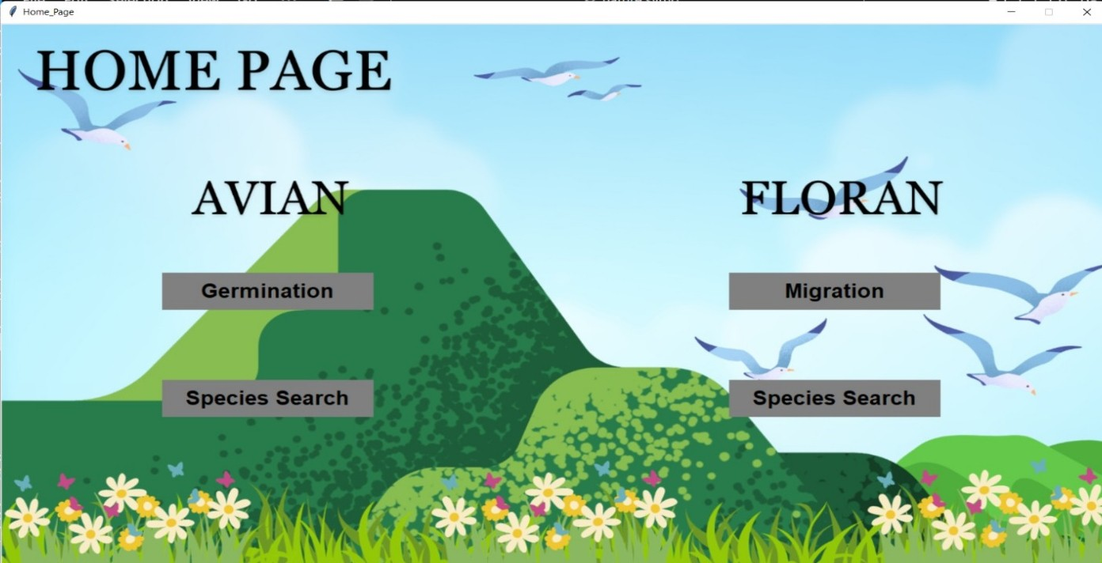

•**If Avian is selected user will be able to know about species of birds and their migration route :**

- Choosing the "Avian" option provides users with a unique opportunity to delve into the diverse world of bird species. Not only can they identify various avian creatures, but they can also explore valuable information about their migration routes. This insight enriches our understanding of the fascinating behaviors and movements of birds, contributing to both scientific knowledge and the enjoyment of birdwatching**.**

•**If Floran is selected, user will be able to know species of flowers and their germination period date :**

- Opting for the "Floral" pathway opens the door to the intricate world of flowering plants and their relationships with birds. Users can accurately predict flower species and access essential data about their germination periods. This feature offers practical information for gardeners and environmental enthusiasts, enhancing their understanding of how different flower species interact with the environment and avian species.

**Chapter 5**

**Software Requirements**

• **Python 3.11.5:**

Python is a popular, high-level programming language. Python 3.11.5 is a specific version of Python, known for its ease of use and extensive libraries. It's used for a wide range of applications, including web development, data analysis, machine learning, and more.

• **MySQL 8.0.1:**

MySQL is an open-source relational database management system. Version 8.0.1 is a specific release of MySQL. It's commonly used to store, retrieve, and manage structured data, making it a popular choice for web applications, content management systems, and data-driven applications.

• **TensorFlow 2.13.0:**

TensorFlow is an open-source machine learning framework developed by Google. Version 2.13.0 is a specific release. It's widely used for building and training deep learning models, including neural networks, for various tasks like image recognition, natural language processing, and more.

• **Websilk 4.11:**

Websilk is not as well-known as the other items on your list. It might be a specific software or library related to web development. However, I couldn't find information about Websilk 4.11 in my training data, so I may not be able to provide detailed information.

• **Google Colab 1.1.2:**

Google Colab, short for Google Colaboratory, is a free cloud-based platform provided by Google that allows users to run Jupyter notebooks in the cloud. It's particularly popular among data scientists and machine learning practitioners. Version 1.1.2 may refer to a specific release of this platform, which can include improvements and bug fixes.

**Chapter 6**

**Project Design**

Nature's Symphony is an ambitious endeavor that aspires to harmonize human understanding with the natural world by predicting the behaviors of birds and the flowering patterns of various plant species. The project arises from the persistent challenge of comprehending these intricate aspects of the natural ecosystem.

At its core, Nature's Symphony offers a visionary solution – it grants users the power to effortlessly identify diverse species of birds and flowers. Through a seamless fusion of advanced data analysis techniques, artificial intelligence, and the wisdom of a global community of nature enthusiasts, this system transforms the complexities of nature into an accessible melody.

Its user-friendly interface acts as a window to the natural world, allowing individuals to discern birds by their songs, plumage, and behaviors. Likewise, it unveils the intricate life cycles and attributes of various flowers with a mere glance through a mobile device. The project emerges as a conduit to forge a profound connection between humanity and the environment.

Yet, Nature's Symphony is more than a tool for identification; it is a wellspring of knowledge. It shares in-depth information about bird species, their migration patterns, and the ecological significance of flora. It acts as a beacon for environmental awareness, nurturing a sense of responsibility and stewardship among its users.

The project doesn't operate in isolation but thrives on community participation. Citizen scientists, nature enthusiasts, and researchers can collaborate to enhance the system's knowledge base, creating a living encyclopedia of the natural world.

As Nature's Symphony unfolds, it weaves a tapestry of interconnectedness. It encourages us to listen to the rhythms of the natural world, learn from its beauty, and cultivate a deeper love for our planet. The project becomes a call to action, reminding us of our collective responsibility to protect and preserve the fragile balance of life on Earth.

In essence, Nature's Symphony is more than a project; it's a bridge between the realms of technology and nature, forging an unbreakable bond between humans and the environment. It invites us to tune in to the symphony of nature and embrace the wonders of the natural world.

**Chapter 7**

**Project Scheduling**

**Project Scheduling Template**

**Sr. No Group Member Time duration Work to be done**

**1 Sanchit Patil**

1st week of July

1st week of August

Implementing 1st module/ functionality (*mention the name of module/ functionality at the place of 1st module/functionality*)

Testing 1st module

(*mention the name of module/ functionality at the place of 1st module/functionality*)

**2 Vanshika Salve** 2nd week of August

Implementing 2nd module/ functionality (*mention the name of module/ functionality at the place of 1st*

*module/functionality*)

**3. Khushi Chhoker** 3rd week of August

By the end of September

**4**

month

Implementing 3rd module/ functionality (*mention the name of module/ functionality at the place of 1st*

*module/functionality*)

**Chapter 8**

**Conclusion**

In a world marked by technological advancements and urban landscapes, *Nature's Symphony* emerges as a profound testament to our enduring connection with the natural world. It embodies the vision of transcending the limitations that have long hindered our understanding of the intricate behaviors of birds and the diverse flowering patterns of plants within the natural ecosystem.

The crux of the matter, the challenge that Nature's Symphony addresses, lies in the intricacies of nature that have eluded our grasp. The migratory patterns of birds stretch across continents, guided by ancient instincts and environmental cues. Meanwhile, the world of flowers blooms in a kaleidoscope of colors and fragrances, driven by an orchestration of factors, both seen and unseen. For too long, these marvels of the natural world have remained beyond the realm of our understanding.

However, Nature's Symphony rises as a solution, an elegantly designed bridge that connects us to the heart of nature. Its core proposition is simple yet profound: the ability to effortlessly identify the myriad species of birds and flowers that grace our world. Through the magic of advanced data analysis, artificial intelligence, and the collective wisdom of an ever-growing community, this system translates the complex language of nature into a familiar and accessible melody.

The user-friendly interface, the soul of Nature's Symphony, presents a window into the natural world. It allows us to discern the essence of birds through their songs, plumage, and behaviors, and reveals the intricate lives of flowers with the mere touch of a mobile device. It invites us to become active participants in the symphony of life, fostering a connection with the environment that is both intuitive and inspiring

Yet, Nature's Symphony is more than an identification tool; it is an educational resource that deepens our connection with the environment. By providing in-depth insights into bird species, their migration routes, and the ecological significance of flowers, it serves as a catalyst for environmental awareness and a renewed sense of responsibility.

Moreover, the project thrives on community engagement. Citizen scientists, nature enthusiasts, and researchers, united by a shared passion for nature, work collaboratively to expand the system's knowledge base. This collective effort transforms the project into a living, breathing tribute to the wonders of the natural world.

As Nature's Symphony unfurls its potential, it weaves a tapestry of interconnectedness, reminding us that we are not separate from nature but integral to

it. It calls upon us to be stewards of the environment, awakening a profound love for our planet and a collective responsibility to safeguard its delicate balance.

In essence, Nature's Symphony is more than a project; it is a symphony in its own right, harmonizing technology and nature, connecting the human heart to the pulse of the natural world. It encourages us to listen, learn, and love, to appreciate the intricate compositions of the environment, and to become champions for the preservation of this precious planet we call home.

**REFERENCES**

<https://www.frontiersin.org/articles/10.3389/fpls.2021.656783>

<https://www.frontiersin.org/articles/10.3389/fpls.2020.590347>

<https://www.kaggle.com/competitions/flower-classification-with-tpus>

**ACKNOWLEDGEMENT**

This project would not have come to fruition without the invaluable help of our guide

<Aavani Nair>. Expressing gratitude towards our HoD, Prof. Anagha Aher, and the Department of Computer Science and Engineering-Data Science for providing us with the opportunity as well as the support required to pursue this project. We would also like to thank our teacher Ms. who gave us her valuable suggestions and ideas when we were in need of them. We would also like to thank our peers for their helpful suggestions.